Ideation Phase
Nutrition Assistant - Brainstorm & Idea Prioritization
Date | 20 July 2026
Team ID
Project Name | Nutrition Assistant Using MERN Stack
Maximum Marks | 4 Marks

Nutrition Assistant - Brainstorm & Idea Prioritization:
This brainstorming session helps the team define practical, user-centered ideas for a Nutrition Assistant built with the MERN stack. Encourage diverse ideas for personalized meal guidance, nutrition tracking, food logging, and health-aware recommendations before evaluating feasibility.
Use this template to collaborate on the Nutrition Assistant concept, group related ideas, and identify the highest-value features for the first release.
Reference: https://www.mural.co/templates/brainstorm-and-idea-prioritization
Step-1: Team Gathering, Collaboration and Select the Problem Statement
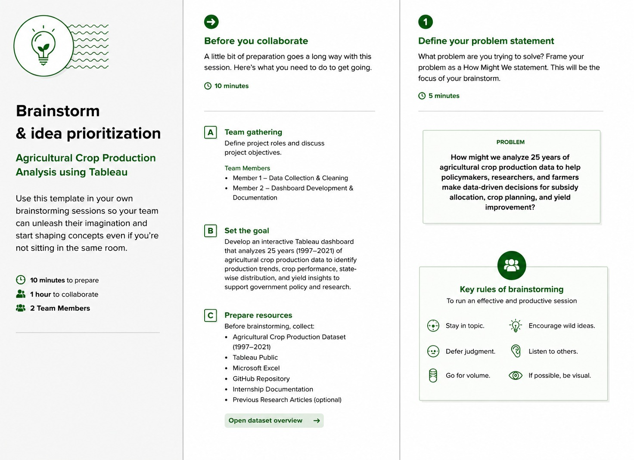
Step-2: Feature Brainstorming, Idea Listing and Grouping
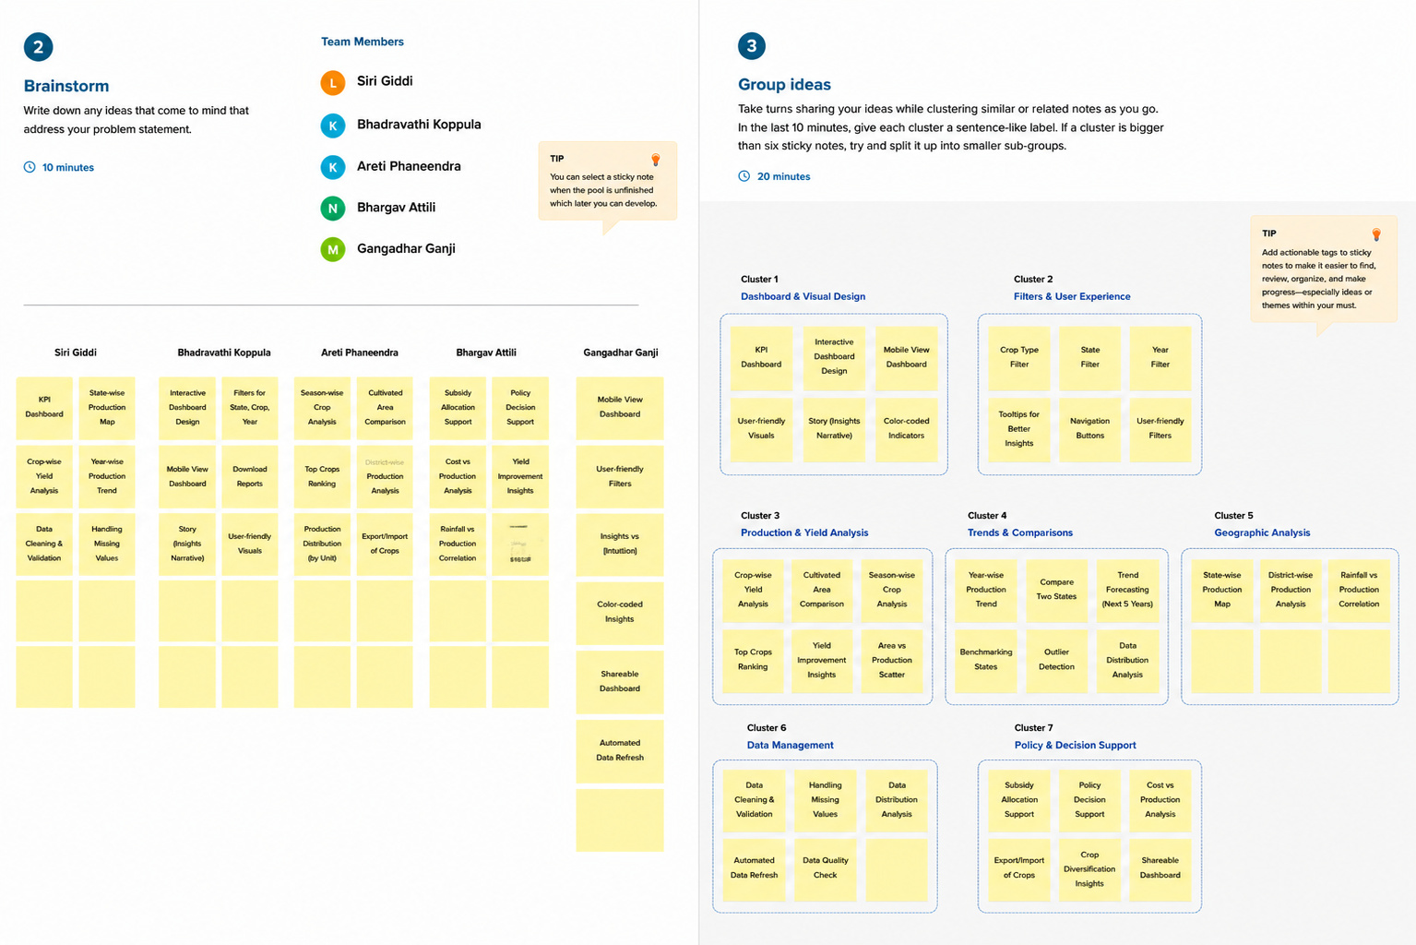
Step-3: Idea Prioritization and MVP Scope Finalization


